Science section

The application of deer antler stem cells in medicine and cosmetology.

***Introduction***

The valuable properties of deer antlers have been known and used in alternative medicine for a long time (in Chinese medicine, the territory of New Zealand and South America). The powdered deer antlers were and are primarily used to accelerate the healing of wounds and fractures, strengthen the body and in the fight against diseases such as osteoporosis, iron deficiency (anaemia), arterial-hypertension or AD, known as atopic dermatitis. The ordinary "stagers" also use them to make tinctures for which recipes can be easily found on the Internet.

***Description***

For several years, research on the properties and possibilities of using deer antlers has also been carried out in the field of convection medicine. The history of these studies begins in Poland, specifically at Wroclaw Medical University. In 2003, employees of this institution visited The Wroclaw Zoological Garden because a fawn damaged his antlers, which were still growing (Cervus elaphus / the red deer). The effect of this intervention, apart from helping the animal, was the removal of tissue fragments from the damaged antlers.



Source: Wikipedia.org

Researchers from the University of Wroclaw isolated the stem cells from the collected tissue and began to multiply them. **Soon after, it got to the groundbreaking discovery!** The stem cells, obtained from red deer antlers, were named Mic-1 (after the names of the researchers and the only woman in the team) and the results of research have been published, indicating their amazing potential. In one of the articles on this subject, we read that Mic-1 multiplies very intensively (the growth of antlers is 1-2 cm per day, which indicates an increased rate of cell division). For this reason, they show great regenerative abilities enabling effective tissue renewal.

Due to the fact that MIC-1 are of animal origin, they also have many similarities to the cells produced by the bone marrow of other animals and humans. The application of MIC-1 in the treatment of diseases and cosmetology is therefore safe, because these cells do not trigger an immune response (e.g. they do not cause an allergic reaction). The research team from the University of Wroclaw also conducted tests aimed at confirming the efficiency of MIC-1 in the treatment of diseases. For example, they conducted in vitro studies on keratinocytesand fibroblasts. The studies have shown that MIC-1 stimulate their renewal, which improves the elasticity of connective tissue and skin. This discovery led to the start of work on production of dermocosmetics based on MIC-1.

*Stem Cells Spin Ltd in Wroclaw*

Due to the difficulties in obtaining funds for further activity, in 2009 the team of discoverers established the company Stem Cells Spin sp. zoo (Ltd), initially with a small share capital in the amount of 50,000PLN. Over time, the company became Stem Cells Spin S.A (JSC) and its share capital increased to 1,293,650PLN in 2014.

The activity of Stem Cells Spin S.A. (JSC) mainly relies on the breeding of MIC-1 and its derivative substances, as well as the development and sale of products derived from them.

*MIC-1 in medicine and cosmetology*

Stem Cells Spin S.A (JSC) develops products intended for sale within various research projects. These projects concern the creation of substances and preparations used in medicine for the regeneration of tendons, cartilage, bones, muscles and nervous tissue, cornea, wound healing or preparations for hair / eyelash growth. Apart from that, they also implement projects aimed at the development of cosmetology. It is mainly about dermocosmetics. For this purpose, Stem Cells Spin S.A has created the Revitacell brand.

*Revitacell*

**Revitacell** has in its offer sets and cosmetics intended for face or eye care. Those are mainly various types of creams, serums or concentrates based on MIC-1 stem cells and derivatives. Manufacturers report that the most important goal of their cosmetics is to mitigate the effects of tissue aging by supporting its regeneration processes after damage caused by biological or external (e.g. environmental conditions) factors.

The prices of these cosmetics are classified as above average which results from the expensive technological process leading to their production. The sets range from 200 to 300 PLN, creams from 100 to 200 PLN and eye and hair concentrates (e.g. eyelashes) from 70 up to 190PLN.

***Conclusion***

Ethical aspects

Due to the fact that dermocosmetics ,offered by Revitacell , are of animal origin, not everyone will be interested in them( mainly people declaring themselves as vegans or activists, fighting against cosmetics testing on animals). ANON, as the international organization, is not critical of the establishment and development of Stem Cells S.A. ( the founder of ANON is a molecular biologist, what allows her for evaluation). However, we are concerned about the fact that MIC-1 are obtained from red deer antlers and we do not know where these antlers come from (rather they are not collected in forest), under what conditions the animals live and if the procedure for collecting antler fragments is safe and painless? We have no information on what it looks like.

There is also the issue of testing the Revitacell products on animals. We know, after consulting with the founder of ANON, that in the case of many substances, drugs or cosmetics, there is no non –invasive, available way of testing them other than on animals. And that is the case with Revitacell dermocosmetics**. It is important to find out how such tests run. Do the participating animals stay in an intact health or perhaps suffer because of the foreseen or not side effects.** We will let you know when we get the relevant information!

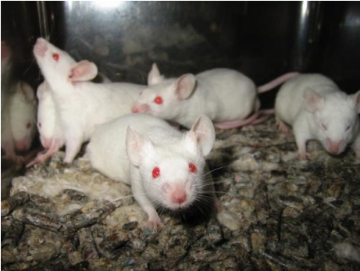Source: Wikipedia.org



